Sopheap Sok

so683950

CIS 3360 0R02, Spring 2018

4/7/2018

Programming Assignment 3: Salted Password

How to compile and run Saltpassword java file:

1. Type **javac Saltpassword.java** to compile.
2. Type **java Saltpassword** to run the program.
3. Program will prompt the user to enter name of file.



1. If the file entered does not exist, the error message below will appear, and the program will terminate.



1. If the file entered is empty, the error message below will appear, and the program will terminate.



1. When an existing and non-empty file is inputted, the dictionary file should appear in the directory and the program will prompt user to enter hash value to compare.



1. When user enter a hash value that is found in the dictionary, the message below will appear.

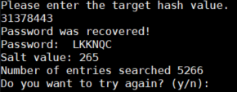

1. If “y” is inputted for the above question, the program will run the comparison again and ask the user to enter a hash value to compare.



1. If user enter a hash value that is not founded, the below message will appear.

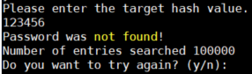

1. If “n” is inputted for the above question, the program will terminate.

